Abstract should be submitted to btnt2019@niser.ac.in by the presenting author (please remove these lines in the final abstract)
Topic:
Title of the abstract (Times New Roman 11 Point)

Author 1, Author 2, Author 3, (Times New Roman 10 point)
Affiliation, Address (Times New Roman 10 point)
Email: (Times New Roman 10 point)

Abstract: The summary should be formatted single-spaced and sized for A4 paper (21 cm × 29.7 cm) with 2.5 cm margins on all sides of the page. Authors are requested NOT to reduce the margin to accommodate more text. All text, references, tables, figures and images should fit on ONE page. (Use Times New Roman 10 point).

1. INTRODUCTION
The abstract title should be written in Times New Roman 11 point bold letters and centered at the top of the first page. The first letter in the title should be Capital. The font should be “Times New Roman 10 point” throughout. The authors’ names (should be written in Full Name), complete organizational affiliations, mailing addresses, and E-mail address of corresponding author should be in 10 pt font size, one line (10 point) below the title as shown above. If the authors are from different institutions, then Arabic numerals should be used after each author name and the corresponding affiliations can be listed one by one.
The abstract of about 100 words should be placed one line (10 point) below the e-mail address. The main text should start two lines below the abstract and be written in a two-column format with 4.5 mm spacing between columns using 10 point font. Indent each paragraph by 3.5 mm.

2. MAJOR SECTIONS
Each major section should begin with a heading in bold capital letters centered within a column and numbered using Arabic numerals except for ACKNOWLEDGEMENT and REFERENCES. Take a one-line blank before the section heading line [1].

2.1. Major subsections
The subsection heading should be left justified in bold letters capitalizing the first letter of each word and numbered using Arabic numerals (2.1, 2.2, …)

2.2. Equations
Equations should be centered in the column and numbered sequentially. Place the equation number to the right of the equation with right justification within its column [2]. An example would be
(1)
When referring to an equation, use the term as ‘eqn.(1)’.

3. FIGURES AND IMAGES
Author(s) may use color traces in graphical data or color photographs. All color traces in graphical data/photograph will be available only in the soft copy of the proceeding. All the colored artwork will appear black and white in the printed version of the proceedings/conference program. Place figure and image captions directly below each figure and image. The captions numbered sequentially using Arabic numerals should be justified. For example,

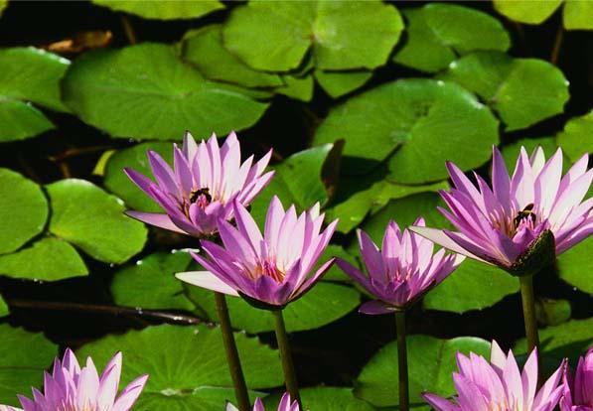
Fig.1. The image in the photograph depicts the view of lotus.

4. TABLES
Place table captions just above each table. The captions numbered sequentially using should be justified. For example,

Table 1. The Table summarizes various parameters calculated in this work.
Col 1 | Col 2 | Col 3 | Col 4 | Col 5
1 | 2 | 3 | 4 | 5
6 | 7 | 8 | 9 | 10

5. REFERENCING
When quoting a reference in the text, place the reference numbers within square brackets. The reference list is placed in the last section. The references should be listed in the order cited as shown in the examples [1-3] below.

ACKNOWLEDGEMENT
If the authors wish to acknowledge…

REFERENCES
[1]. X. Yu et al, Appl. Phys. Lett. 31 (2013) 1991.
[2]. A.B.C. Number and B.C.D. Text, The book on the references, vol. 3, Kluwer Academic Press, New York, 1992.

